**IAM TASKS :**

1. **Create one IAM user and assign ec2,s3 full access role.**

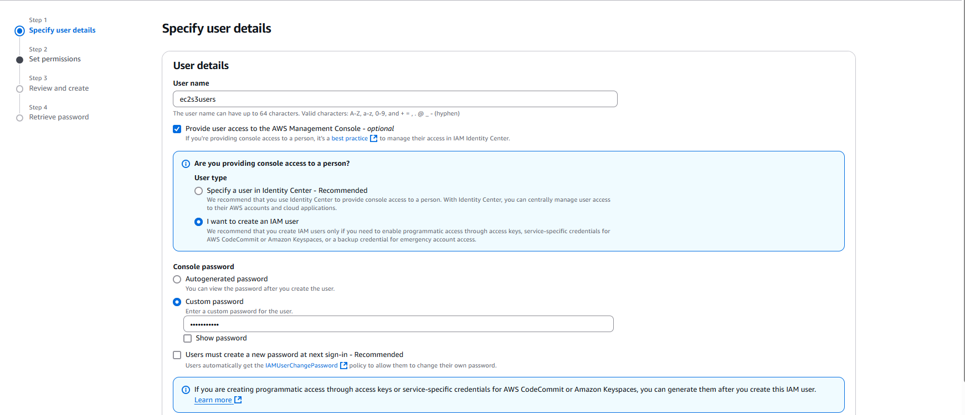

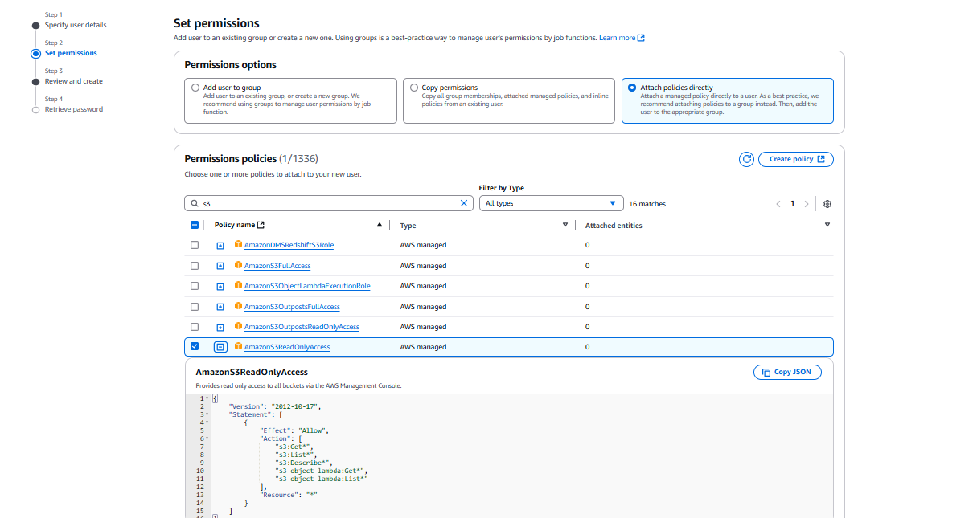

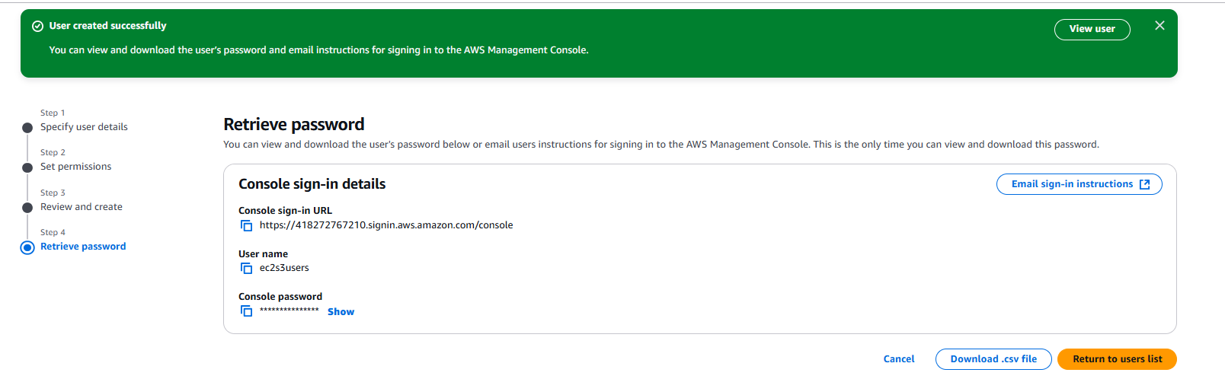

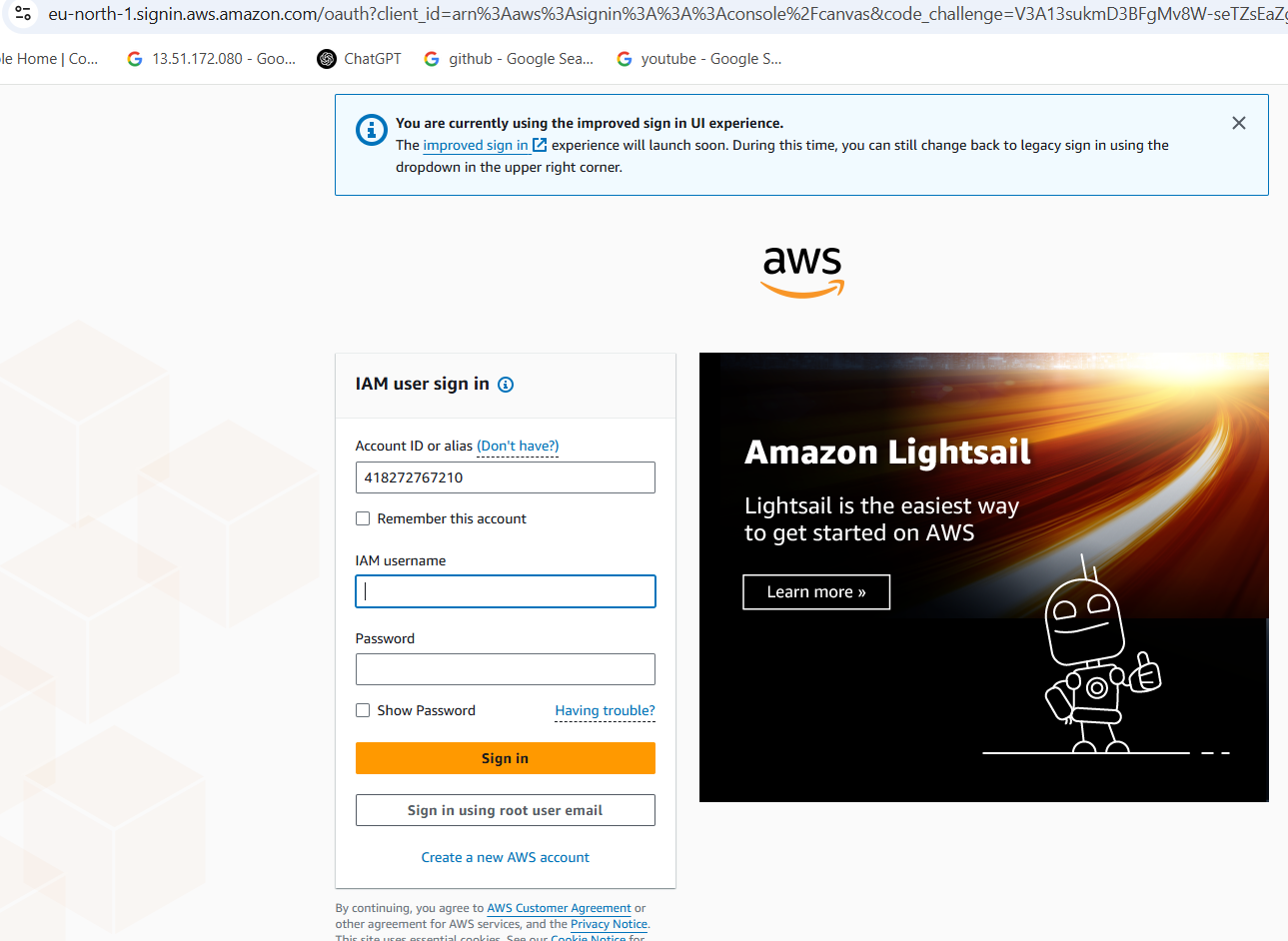

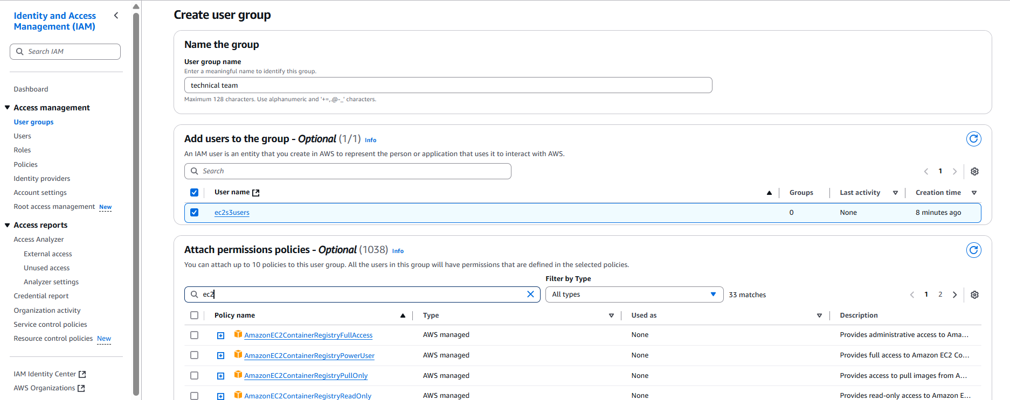

1. **Create one Group in IAM and Assign Read access for ec2.**

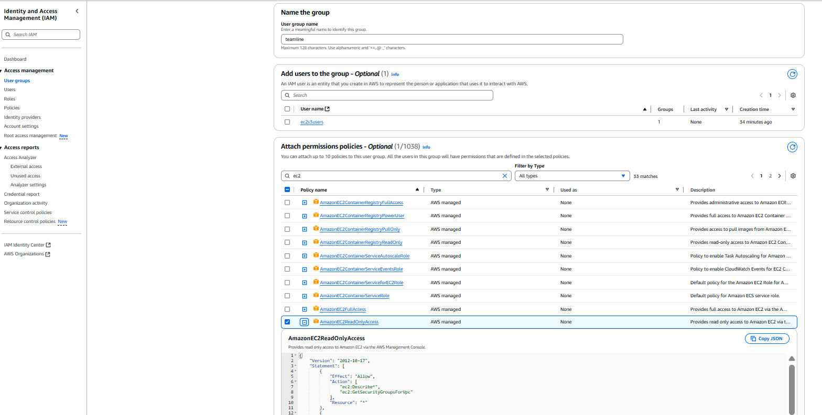

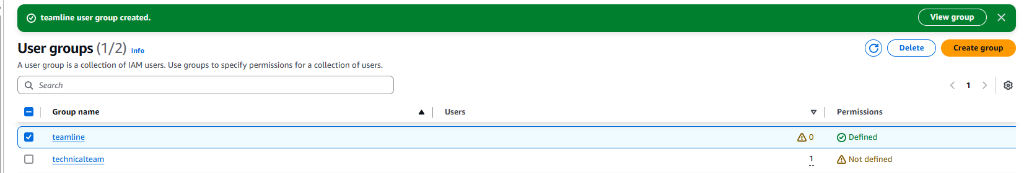

1. **Create a new user with name Devops and add to the group created in task2.**

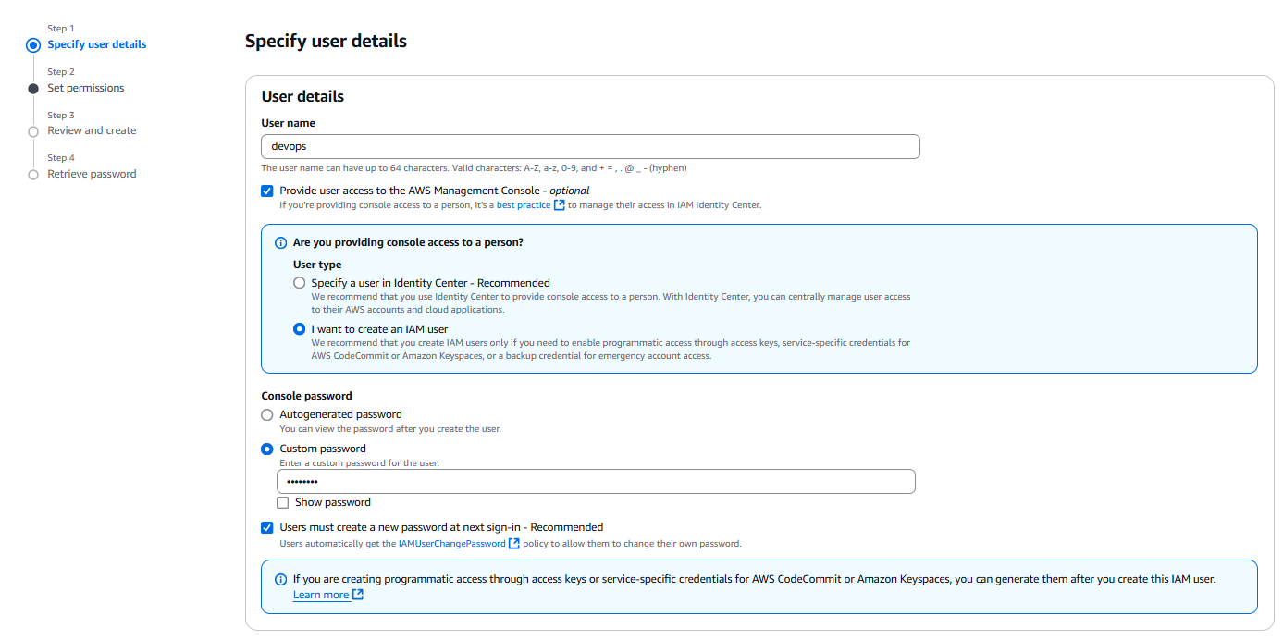

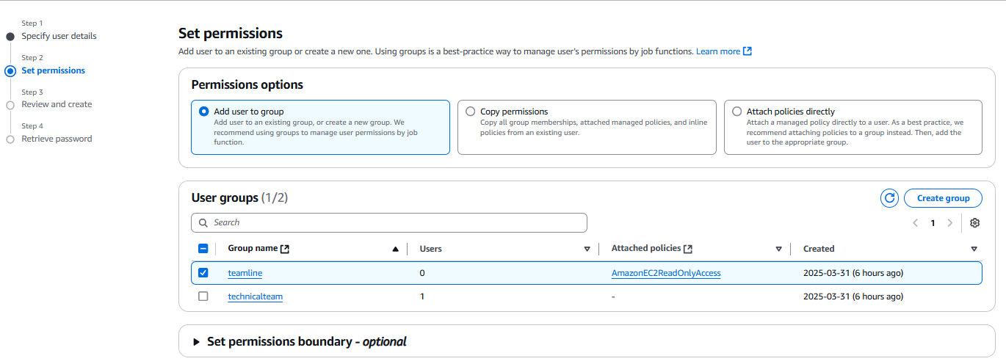

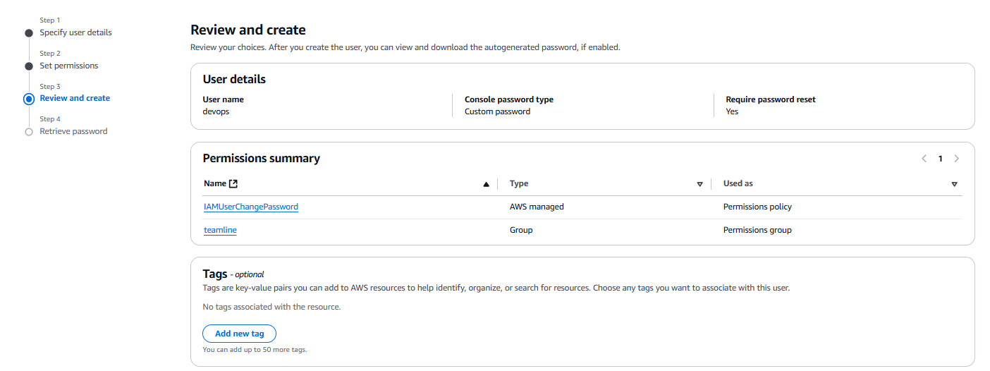

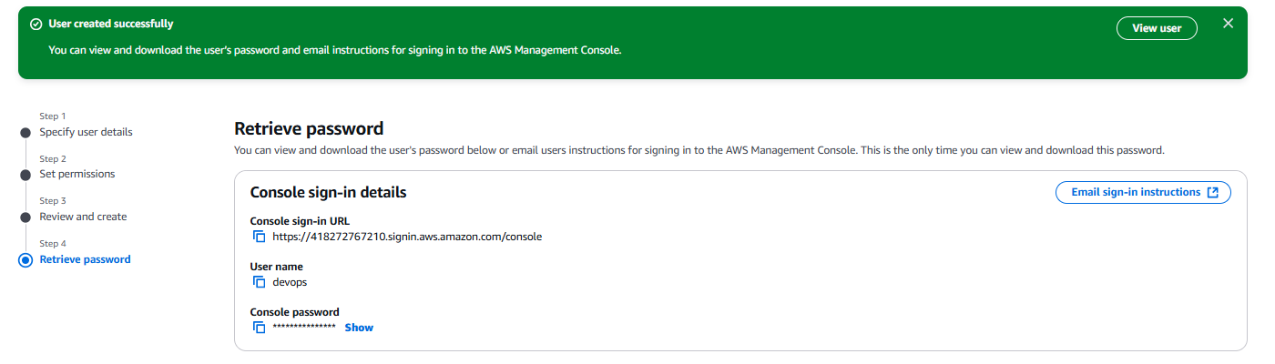

1. **Write a bash script to create a IAM user with VPC full access.**

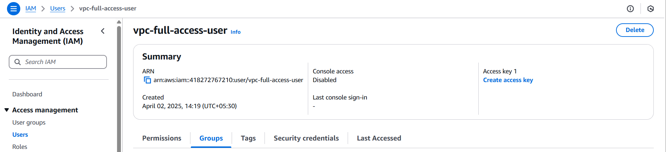

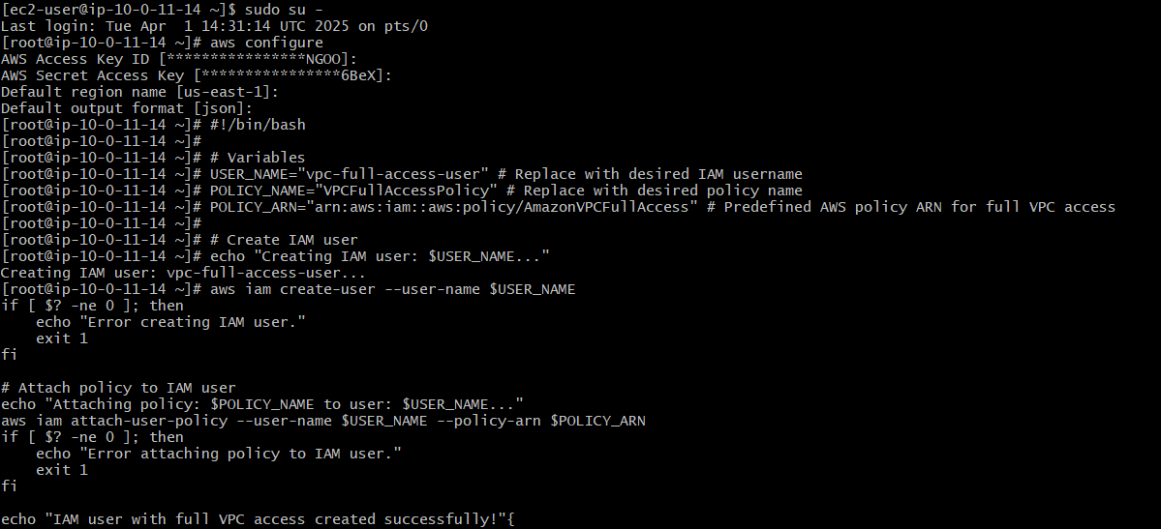

1. **Create a IAM policy to access ec2 for a specific user in specific regions only.**

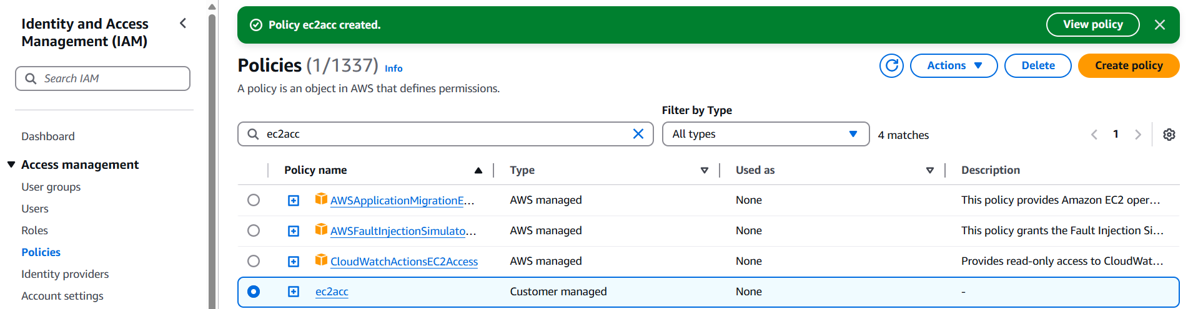

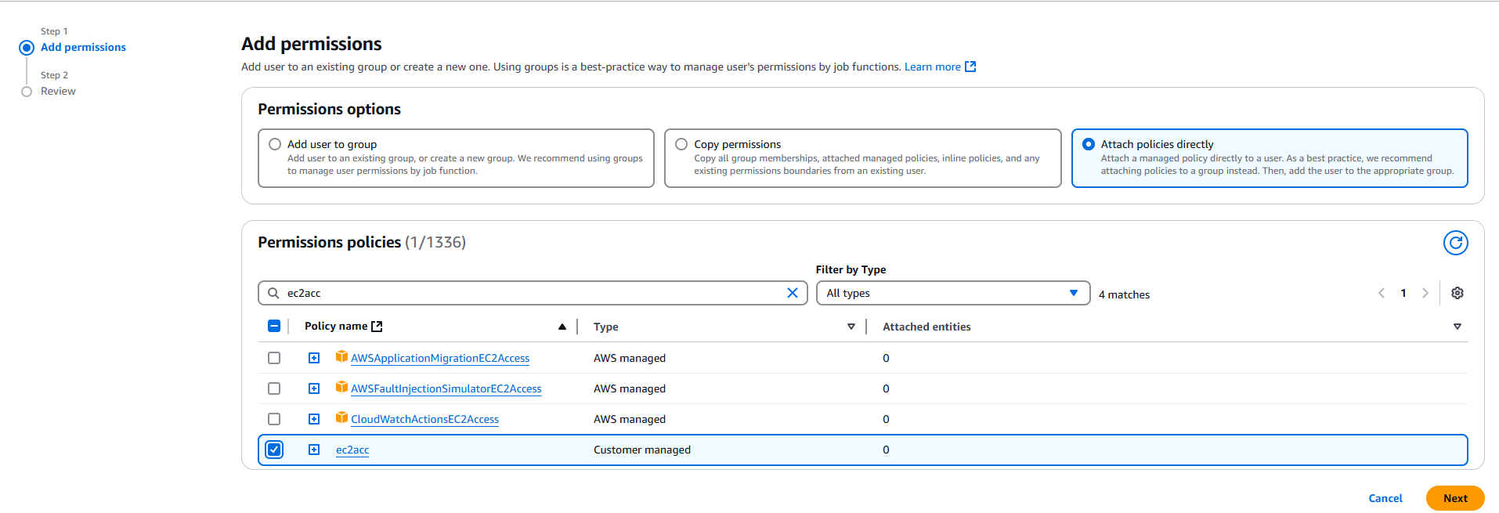

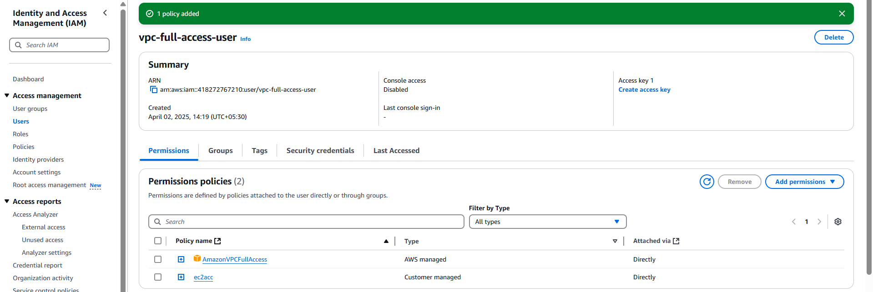

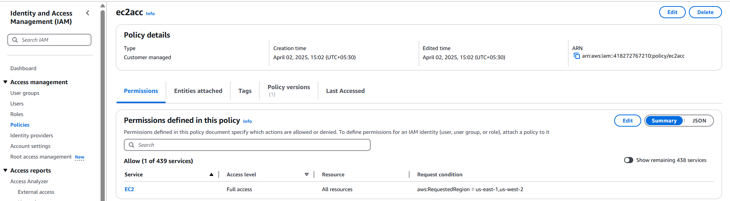

1. **We have two accounts Account A and Account B, Account A user should access s3 bucket in Account B. (Collaborate with team member and execute this.Mostly asked in every interview)**



